CSE1007 – Lab Exercise on Collections Framework

# Question 1

**Write a Java Program to store the 5 words using ArrayList and display the words which are palindrome from the 5 words.**

**CODE:**

import java.util.*;

public class q1{

public static boolean isPalindrome(String s)

{

String rev="";

for(int i=s.length()-1;i>=0;i--)

rev+=s.charAt(i);

if(s.equals(rev))

return true;

else

return false;

}

public static void main(String[] args)

{

Scanner in = new Scanner(System.in);

int i;

String s;

ArrayList <String> words = new ArrayList<String> ();

System.out.print("Enter n: ");

int n=in.nextInt();

System.out.println("\nEnter "+n+" words: ");

for(i=0;i<n;i++)

{

s=in.next();

words.add(s);

}

Iterator itr= words.iterator();

System.out.println("\nPalindrome Words: ");

while(itr.hasNext())

{

s=(String) itr.next();

if(isPalindrome(s))

System.out.println(s);

}

}

}

**OUTPUT:**

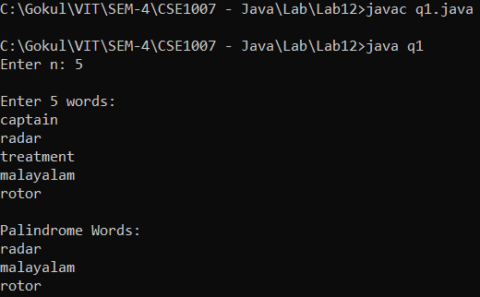

# Question 2

**Develop a Java program to create an ArrayList of Floating point data type with 5 user input elements and find the mean, mode and standard deviation of all the elements from the ArrayList and store the mean, mode and standard deviation in 5th,6th, and 7th positions respectively.**

**CODE:**

import java.util.*;

public class q2 {

public static float mode(float[]Ar, int n)

{

int i,j,count,max=0;

float f=0;

for(i=0;i<n-1;i++)

{

count=0;

for(j=i+1;j<n;j++)

{

if(Ar[i]==Ar[j])

count++;

}

if(count>max)

{

max=count;

f=Ar[i];

}

}

return f;

}

public static double sd(float mean, float[]Ar, int n)

{

float sDev=0;

for(int i=0;i<n;i++)

sDev += Math.pow(Ar[i] - mean, 2);

return Math.sqrt(sDev/n);

}

public static void main(String[] args)

{

Scanner in = new Scanner(System.in);

int i,n=5;

float f,total=0;

float[] Ar = new float[n];

ArrayList <Float> list = new ArrayList <Float> ();

System.out.println("Enter "+n+" Floating point values: ");

for(i=0;i<n;i++)

{

f=in.nextFloat();

list.add(f);

}

Iterator itr = list.iterator();

i=0;

while(itr.hasNext())

{

f=(float)itr.next();

total+=f;

Ar[i++]=f;

}

float mean=total/n;

System.out.println("\nMean = "+mean);

System.out.println("Mode = "+mode(Ar,n));

System.out.println("SD = "+sd(mean,Ar,n));

}

}

**OUTPUT:**

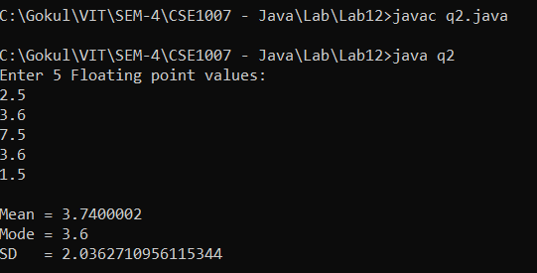

# Question 3

**Create a class bank with account number, name, bank_branch_name, and balance. Store the details of 10 customers either using parameterized constructor or through user input in a Java Collection LinkedList. Provide the facility to do the following**

1. **Display the details of the customers who have balance greater than 50000Rs**
2. **Display the sum of all the account holders in a particular branch.**

**CODE:**

import java.util.*;

class bank

{

int ANo;

String name, bname;

double balance;

Scanner in = new Scanner(System.in);

bank()

{

System.out.print("Enter Account No: ");

ANo=in.nextInt();

System.out.print("Enter Name: ");

name=in.next();

System.out.print("Enter branch name: ");

bname=in.next();

System.out.print("Enter Balance: ");

balance=in.nextDouble();

}

}

public class q3

{

public static void main(String[] args)

{

Scanner in = new Scanner(System.in);

int i,n=10,ch;

String branch;

double dep=0;

LinkedList <bank> list = new LinkedList <bank> ();

for(i=0;i<n;i++)

{

System.out.println("\nEnter Details of Customer "+(i+1)+": ");

bank b = new bank();

list.add(b);

}

Iterator itr = list.iterator();

System.out.println("\nAcc No\tName\tBranch\tBalance");

while(itr.hasNext())

{

bank b=(bank)itr.next();

System.out.println(b.ANo+"\t"+b.name+"\t"+b.bname+"\t"+b.balance);

}

while(true)

{

System.out.println("\n1. Display the details of the customers who have balance greater than Rs.50000");

System.out.println("2. Display the sum of all the account holders in a particular branch\n3. Exit");

System.out.print("Enter your choice: ");

ch=in.nextInt();

if(ch==1)

{

itr = list.iterator();

System.out.println("\nAcc No\tName\tBranch\tBalance");

while(itr.hasNext())

{

bank b=(bank)itr.next();

if(b.balance>50000)

System.out.println(b.ANo+"\t"+b.name+"\t"+b.bname+"\t"+b.balance);

}

}

else if(ch==2)

{

itr = list.iterator();

System.out.print("Enter branch name: ");

branch=in.next();

System.out.println("\nAcc No\tName\tBranch\tBalance");

while(itr.hasNext())

{

bank b=(bank)itr.next();

if(b.bname.equals(branch))

{

System.out.println(b.ANo+"\t"+b.name+"\t"+b.bname+"\t"+b.balance);

dep+=b.balance;

}

}

System.out.println("\nTotal Deposit in "+branch+" branch: "+dep);

}

}

}

}

**OUTPUT:**

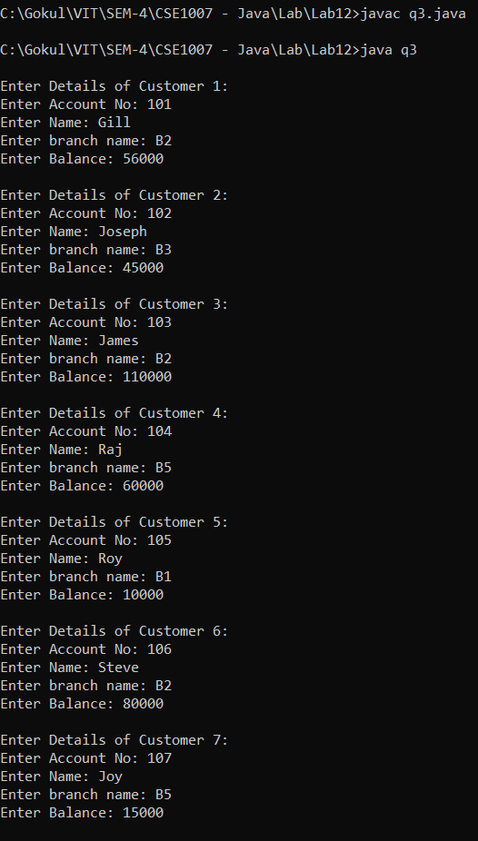

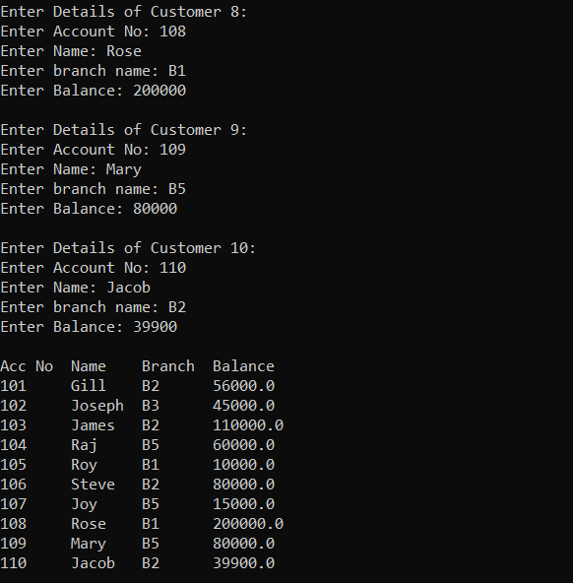

# 

# Question 4

**Write a method that takes a string and returns the number of unique characters in the string. It is expected that a string with the same character sequence may be passed several times to the method. Use collections and maps where appropriate.**

**Include a main method to test harness the above method.**

**CODE:**

import java.util.*;

public class q4{

public static int count(String str)

{

char [] c=new char[str.length()];

c=str.toCharArray();

HashSet<Character> hs=new HashSet<Character>();

for(char x:c)

hs.add(x);

System.out.println("\nUnique Characters: "+hs);

return hs.size();

}

public static void main(String[] args)

{

Scanner in = new Scanner(System.in);

int i;

System.out.print("Enter a string: ");

String s=in.next();

System.out.println("No:of unique characters: "+count(s));

}

}

**OUTPUT:**

